Website – 7 Wonders

# Analysis

## Features of website

The website "7 Wonders" is a digital platform that aims to inform and educate people about the new Seven Wonders of the World. The website's main focus is to provide information about the seven new wonders, which are the Colosseum in Rome, the Great Wall of China, the Taj Mahal in Agra, Christ the Redeemer in Rio de Janeiro, Machu Picchu in Peru, Chichen Itza in Mexico, and Petra in Jordan.

The website is designed with a clean and modern layout, making it easy to navigate and find the information that users are looking for. The website's home page features a slideshow of images of the seven new wonders, with short caption of each one. Users can click on the buttons in the navigation bar to access more detailed information about each wonder, including its history, build, location, and interesting facts.

In addition to the information provided about the wonders, the website also includes a section dedicated to feedback. The feedback page allows users to provide their thoughts and opinions about the website and the wonders featured on it. This page includes a form that users can fill out to submit their feedback, including their name, email address, and the wonder they visited. This feature is beneficial for the website's stakeholders as it allows them to gather valuable insights and improve the website based on user feedback.

## Research of similar websites

## Research of other websites that talk about the 7 wonders of the world revealed that there are a variety of options available.

## One website, "New7Wonders.com", focuses specifically on the 7 wonders as determined by the New7Wonders Foundation. This website has a clean and visually appealing design, with high-quality images and videos of the sites. The website also includes interactive maps and virtual tours, providing an immersive experience for the users. A downside of this website is that the information about each site is limited, and it does not include much historical or cultural context.

## Another website, "7Wonders.org”, has a user-friendly design and easy navigation. It provides a variety of information about each site, including historical background, cultural significance, and current preservation efforts. The website also includes user-generated content such as photos and reviews. However, it may lack some multimedia contents and interactive features compared to other websites.

Another website that talks about the 7 wonders of the world is "7WondersTravel.com". This website offers a guide to visiting the 7 ancient and new wonders of the world, providing information on how to get there, what to see, and where to stay. The website features a user-friendly design and easy navigation, with sections for each wonder, including photos, videos, and interactive maps. The website also includes information about tour packages and travel deals, making it a useful resource for planning a trip to see the 7 wonders. However, it may not be an ideal website for researchers or for those looking for more in-depth information about history and culture of the sites.

It's important to note that these are just a few examples of websites that talk about the 7 wonders of the world, and there are many other options available. Each website has its own strengths and weaknesses.

## Stakeholder

## The stakeholders of a website about the new 7 wonders of the world are diverse and can be grouped into several categories.

## Tourists: The primary stakeholder group of this website would be tourists interested in visiting the new 7 wonders of the world. These individuals would use the website to research and plan their trip, including information on the location, history, and cultural significance of each wonder. They could also use the website to book travel arrangements, such as flights and accommodations.

## Educators and Students: Another stakeholder group would be educators and students studying world history and culture. The website would provide them with detailed information about the new 7 wonders, as well as educational resources such as lesson plans and activities.

## Researchers: Researchers in fields such as archaeology, anthropology, and architecture would also be stakeholders of this website. They would use the website to access detailed information about the new 7 wonders for their research projects and papers.

## Local Communities: The local communities near each of the new 7 wonders would also be stakeholders of the website. The website could promote tourism to these areas, which would benefit local businesses and economy. Additionally, the website could showcase the cultural heritage of these communities, helping to preserve it for future generations.

## Finally, the website would also be beneficial for governments and organizations responsible for the preservation and promotion of these new 7 wonders. They would use the website to reach a larger audience, increase awareness and funding for preservation efforts, and promote tourism.

## Overall, the website would serve as a valuable resource for a wide range of stakeholders, providing information, resources, and opportunities for education, research, and tourism. It would also help to promote and preserve the cultural heritage of these new 7 wonders for future generations.

## Success Criteria

* High traffic: The website should attract a significant number of visitors on a regular basis.
* Positive user experience: Users should find the website easy to navigate, visually pleasing, and informative.
* High conversion rate: A large percentage of visitors should feel informed.
* Positive feedback: Users should provide positive feedback about the website through reviews, testimonials, or social media.
* Good performance: The website should load quickly and be accessible on multiple devices and platforms.

# Design and top-down decomposition

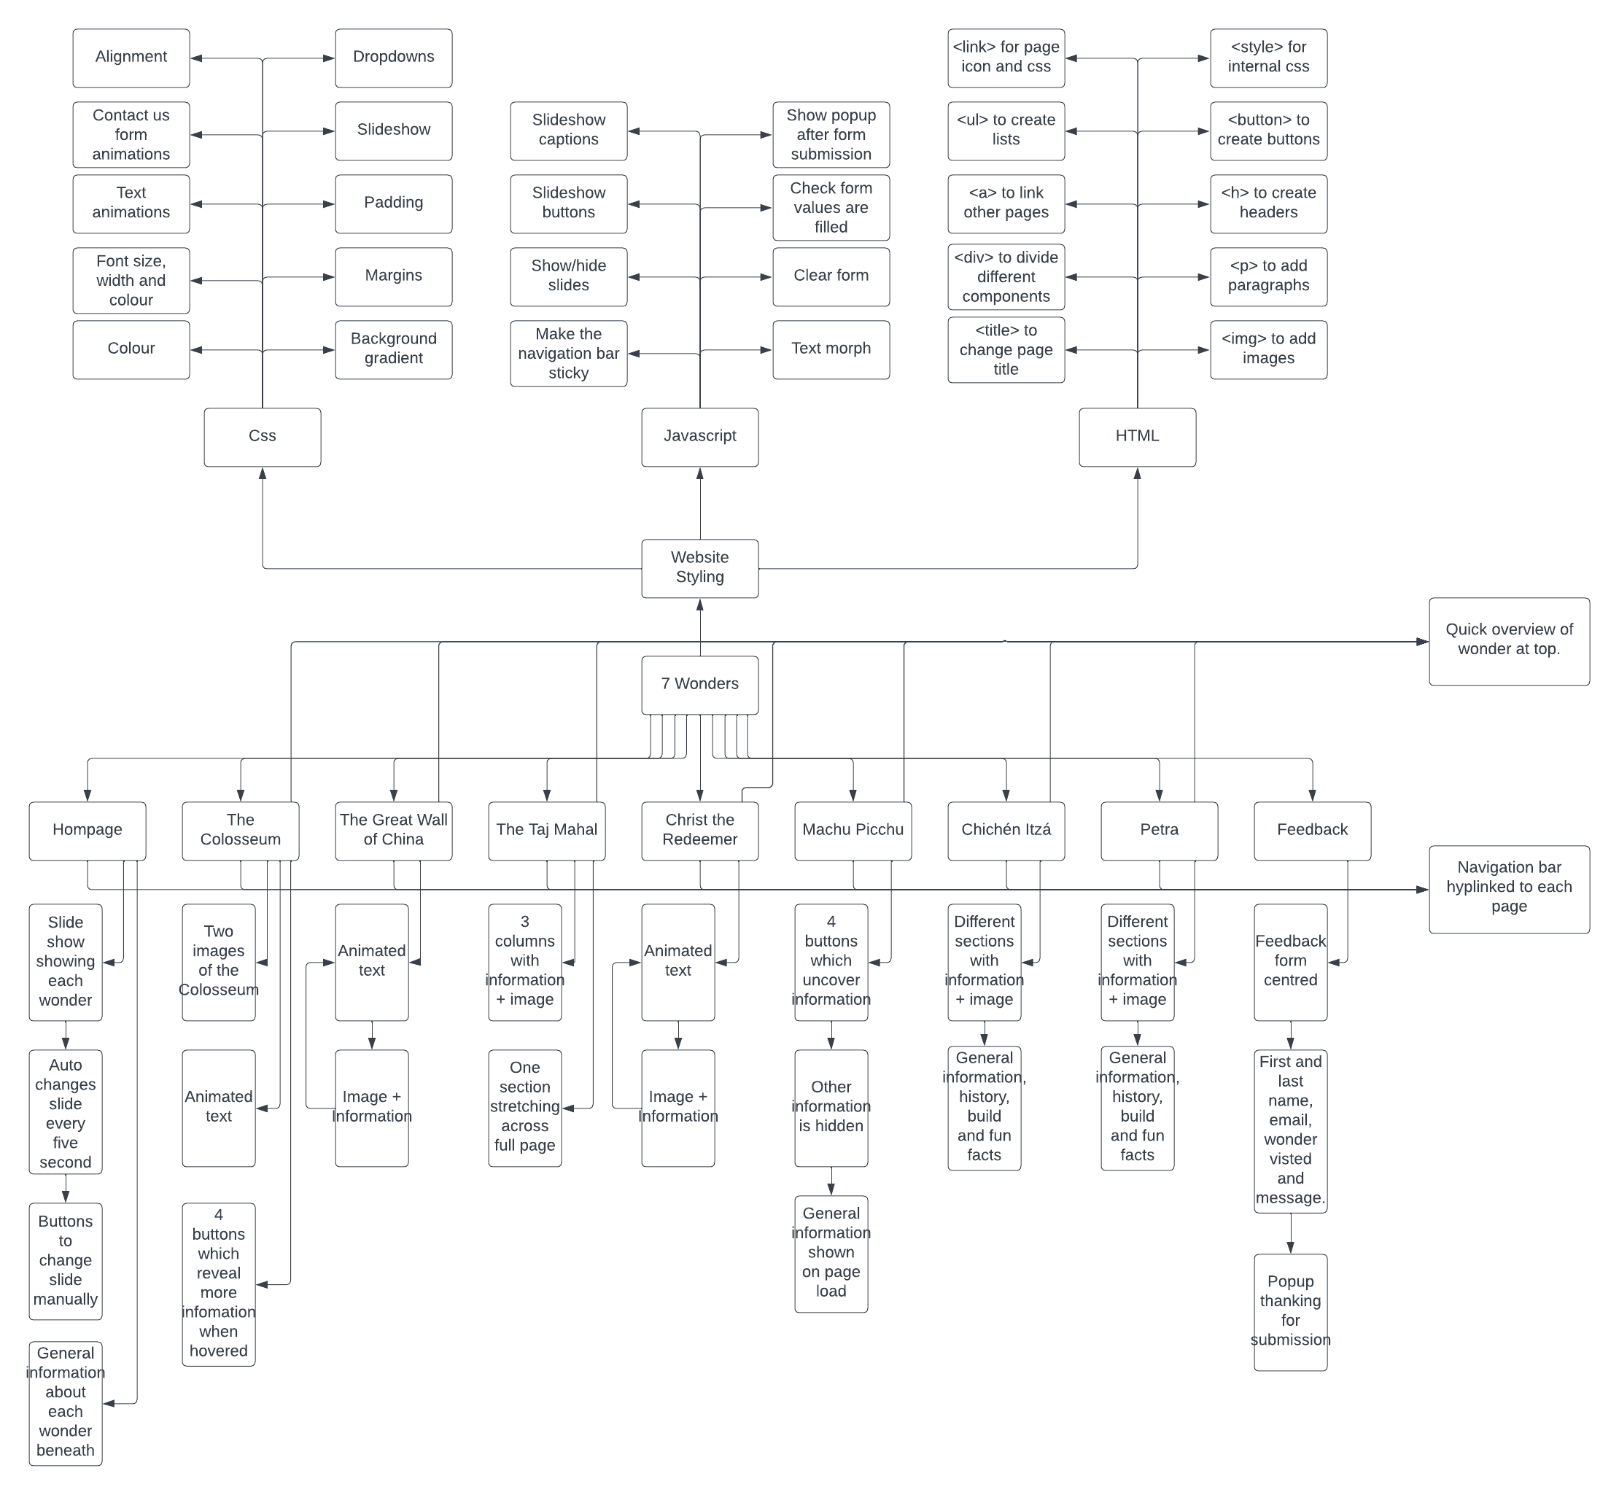

<https://file.coffee/u/EYslcGMVYyTNxxk5P3WL8.png> (Link to online image if the image above is not legible)

|  |
| --- |
| Homepage  Short paragraphs generally talking about the 7 wonders of the world.  Slideshow + caption  Logo  Navigation bar |

|  |
| --- |
| The Colosseum  4 labels – general information, history, build and fun facts. When hovered over, more information will be revealed and when the cursor leaves the information and the label, the information will disappear.  Quick overview about the wonder  Navigation bar |

|  |
| --- |
| The Great Wall of China  Information  Header  Information  Header  Navigation bar  Quick overview about the wonder |

|  |
| --- |
| The Taj Mahal  Box – Header + information/bullet points  Column 3 – Header + Information  Column 2 – Header + Information  Column 1 – Header + Information  Navigation bar  Quick overview about the wonder |

|  |
| --- |
| Christ the redeemer  Navigation bar  Quick overview about the wonder  Information  Header  Information  Header |

|  |
| --- |
| Machu Pichu  Header Information  Header 4  (Button)  Navigation bar  Quick overview about the wonder  Header 3  (Button)  Header 2  (Button)  Header 1  (Button) |

|  |
| --- |
| Chichén Itzá  Header Image Information  Image Header  Information  Header Image Information  Quick overview about the wonder  Navigation bar |

|  |
| --- |
| Petra  Header Image Information  Header Image Information  Image Header  Information  Quick overview about the wonder  Navigation bar |

|  |
| --- |
| Feedback  Submit button (animated popup when pressed)  Contact us form: First name Last name Email Address Wonder visited Message |

The design of the 7 Wonders website has been meticulously crafted to promote ease of navigation and user engagement. The website features a persistent navigation bar that remains in the same location throughout all pages, allowing users to effortlessly move between sections of the site. The currently selected page is easily distinguishable through the highlighted green tab on the navigation bar.

Each page of the website has been individually designed to hold the visitor's attention and maintain their interest. The website incorporates interactive elements to engage users and add a touch of excitement. These interactions are accompanied by visually appealing animations that highlight the responsiveness of the site, further enhancing the user experience.

In an effort to create a dynamic and lively atmosphere, the website employs the use of animated text to bring a unique flair to the overall presentation. The combination of an intuitive design, engaging elements, and visually appealing animations make for a truly immersive and enjoyable user experience.

# Implementation

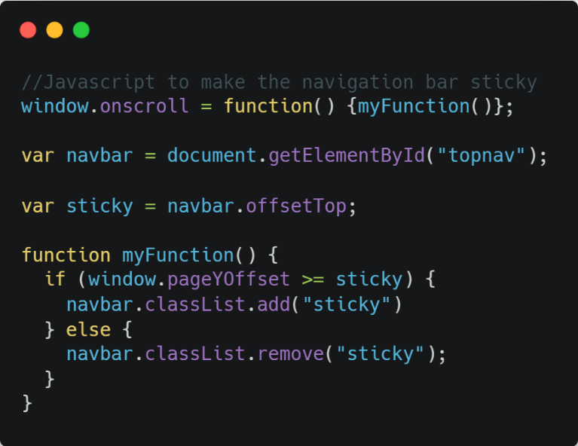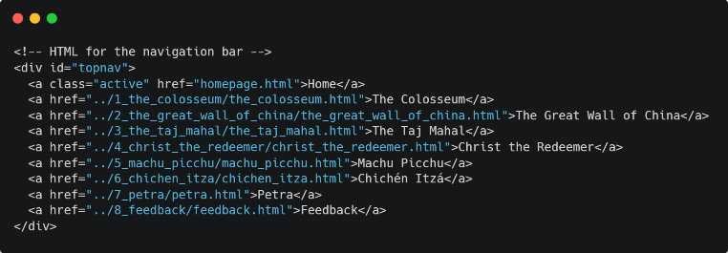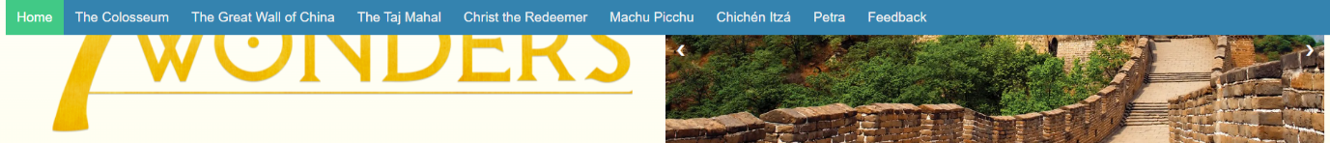**Navigation bar**: A common feature present on most websites is the sticky navigation bar, which is designed to remain fixed at the top of the webpage as the user scrolls down. This navigation bar provides a consistent and convenient access point for navigation, allowing users to easily access important sections or pages on the site without having to scroll back to the top of the page. The sticky navigation bar is an important design element that enhances user experience and navigation on a website.

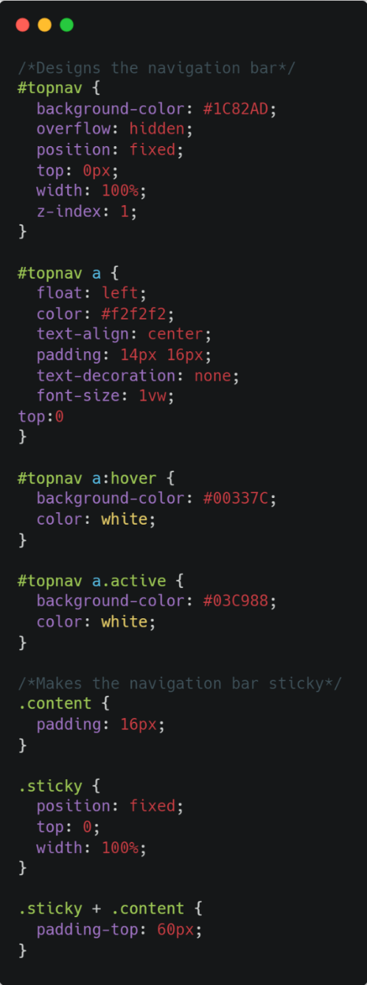

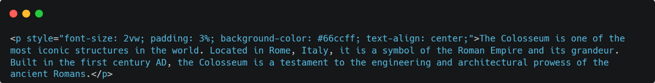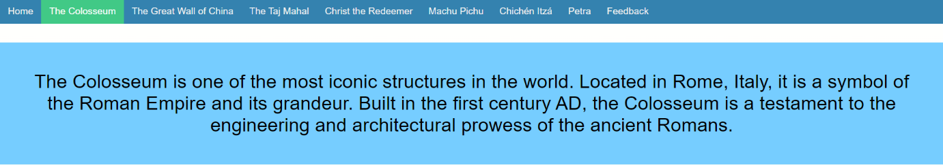**Summary**: Each page, excluding the homepage and feedback page, on the website features a concise summary or overview of the corresponding wonder at the top of the page. This brief introduction serves to provide a quick and easily digestible overview of the wonder, giving users a high-level understanding of its significance and unique characteristics. This design element serves to provide a clear and efficient orientation for the user and highlights the important information about each wonder, making it easier for users to navigate and understand the content on the website.

Each page on the website will be linked to its own dedicated external cascading style sheet (CSS) file. This CSS file will provide a consistent and centralized source of styling information, allowing for a streamlined and maintainable design across the site. Additionally, each page will feature the page name as a clear and identifiable title, as well as a link to a relevant page icon. The font used on each page will be described within a style tag, providing a clear and consistent typographical styling throughout the website. This combination of elements serves to ensure a cohesive and professional visual design for each page, providing a consistent and easily navigable user experience for visitors to the website. 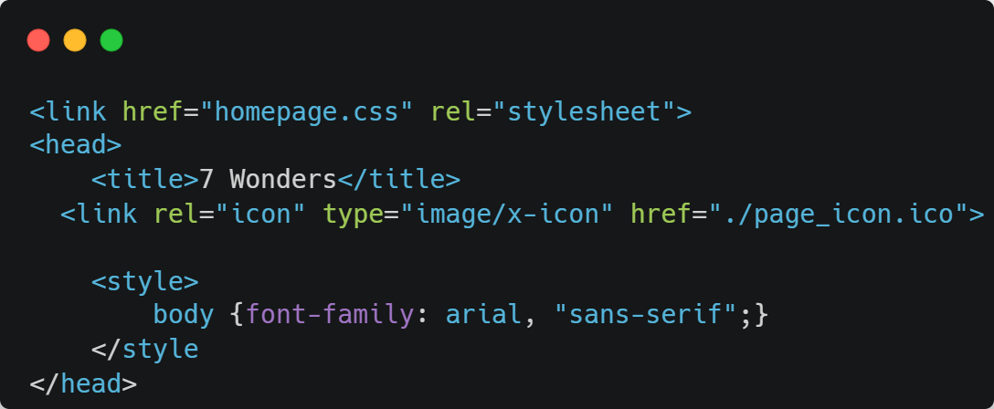

### Homepage

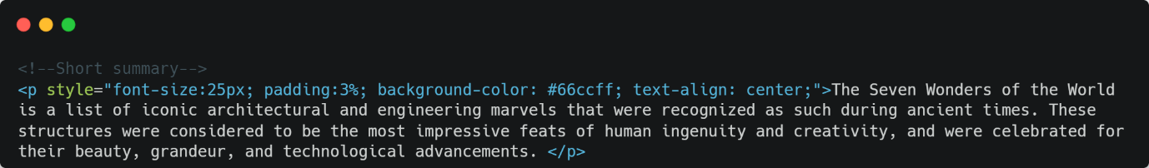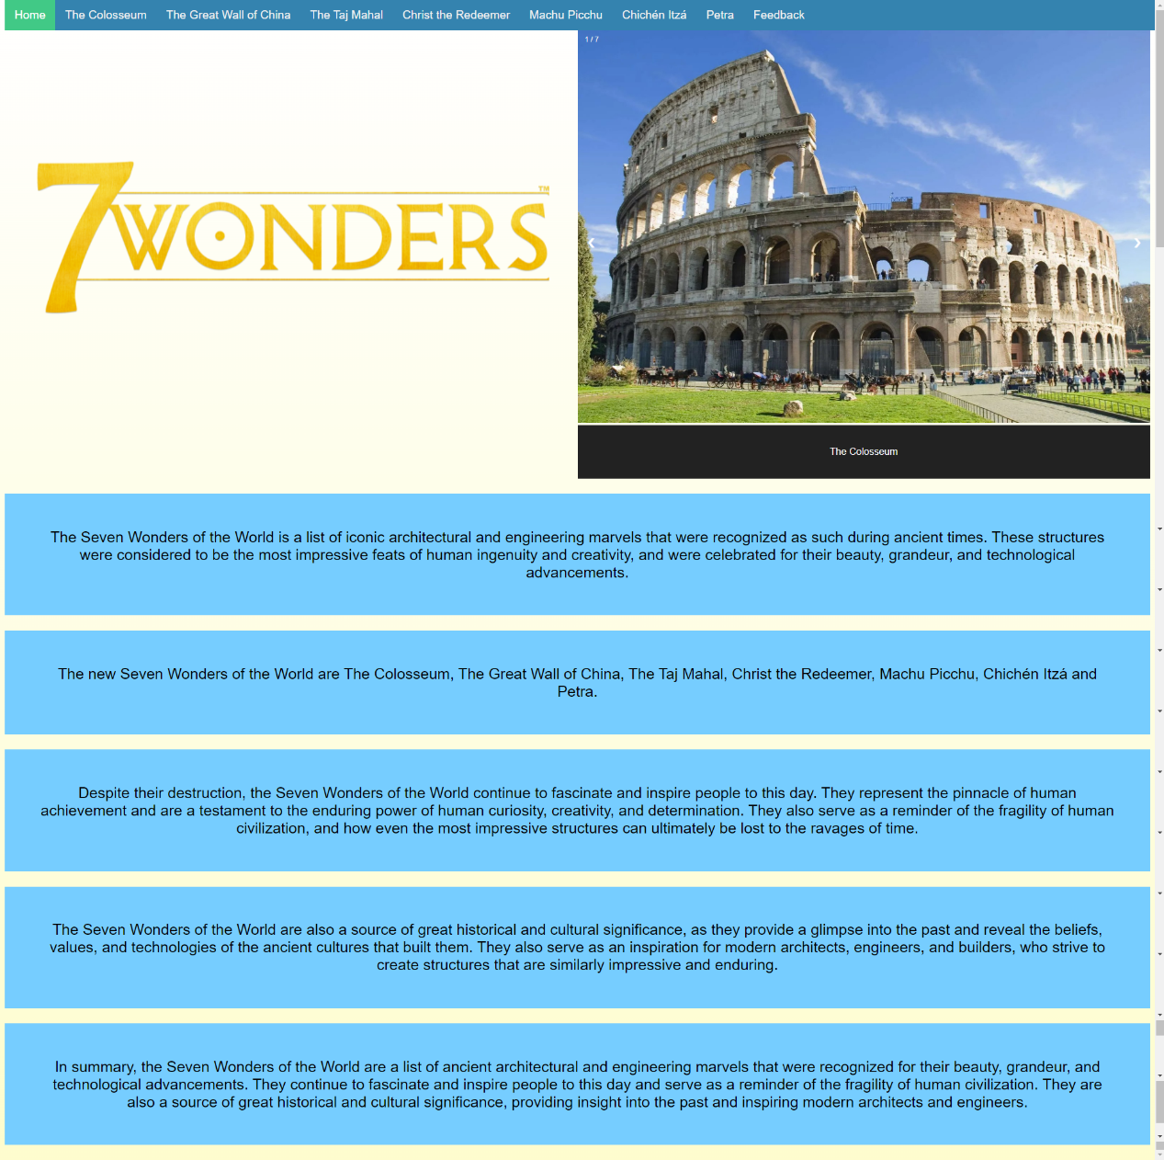 The homepage of our website features a visually engaging slideshow that highlights each of the Seven Wonders of the World. The slideshow is accompanied by a prominently displayed logo, which serves to establish branding and visual continuity throughout the site. Beneath the slideshow, a concise yet informative summary of the Seven Wonders is provided, offering visitors a brief overview of the historical and cultural significance of these iconic structures. The overall layout and design of the homepage has been carefully crafted to provide a seamless and intuitive user experience, allowing visitors to easily navigate and engage with the content.

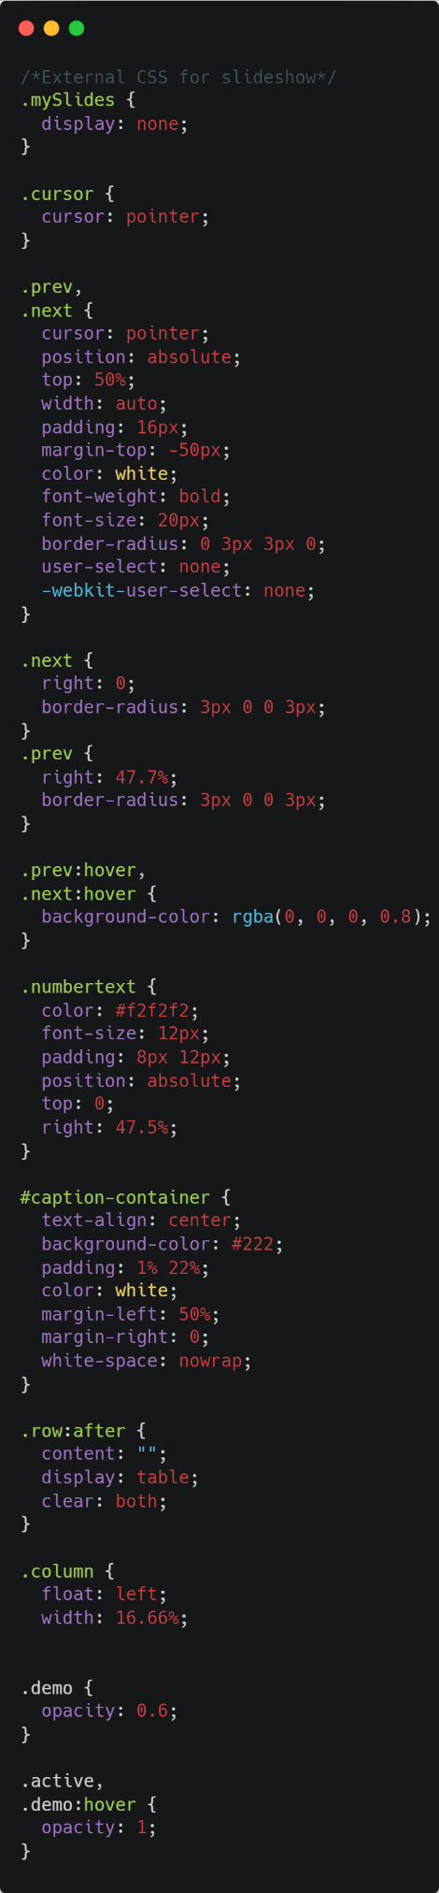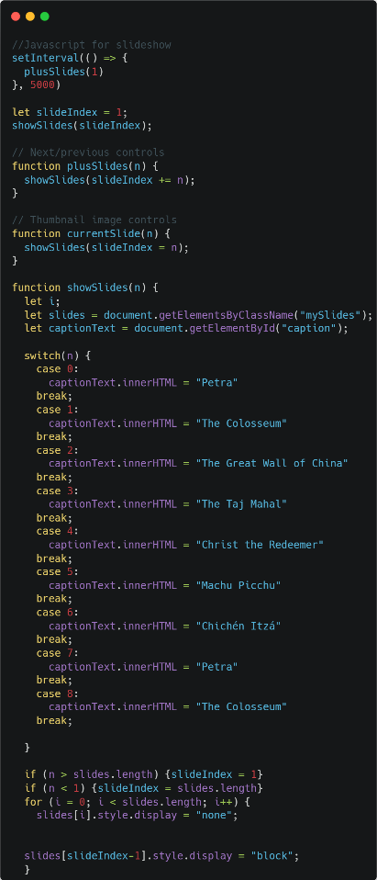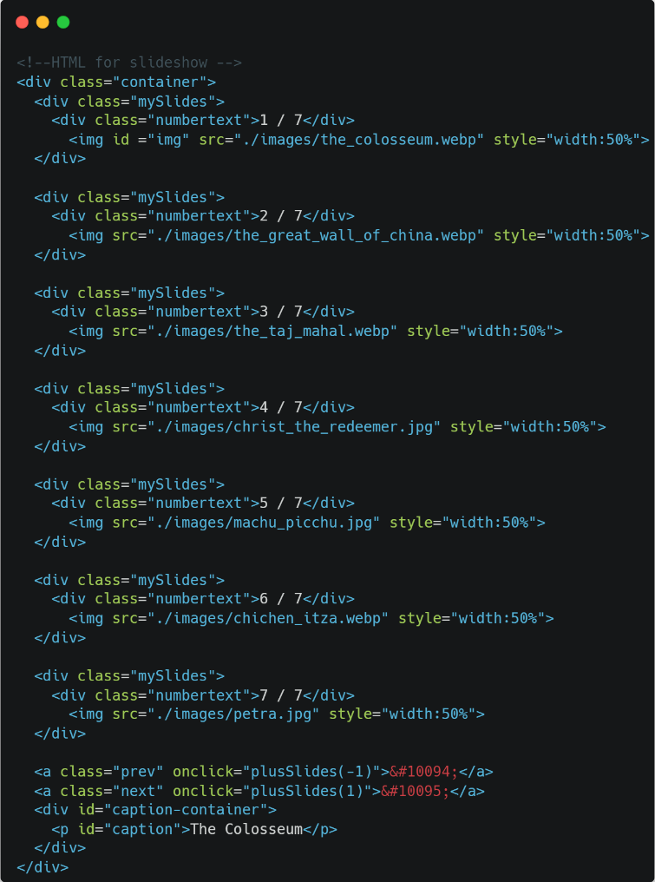

## The Colosseum

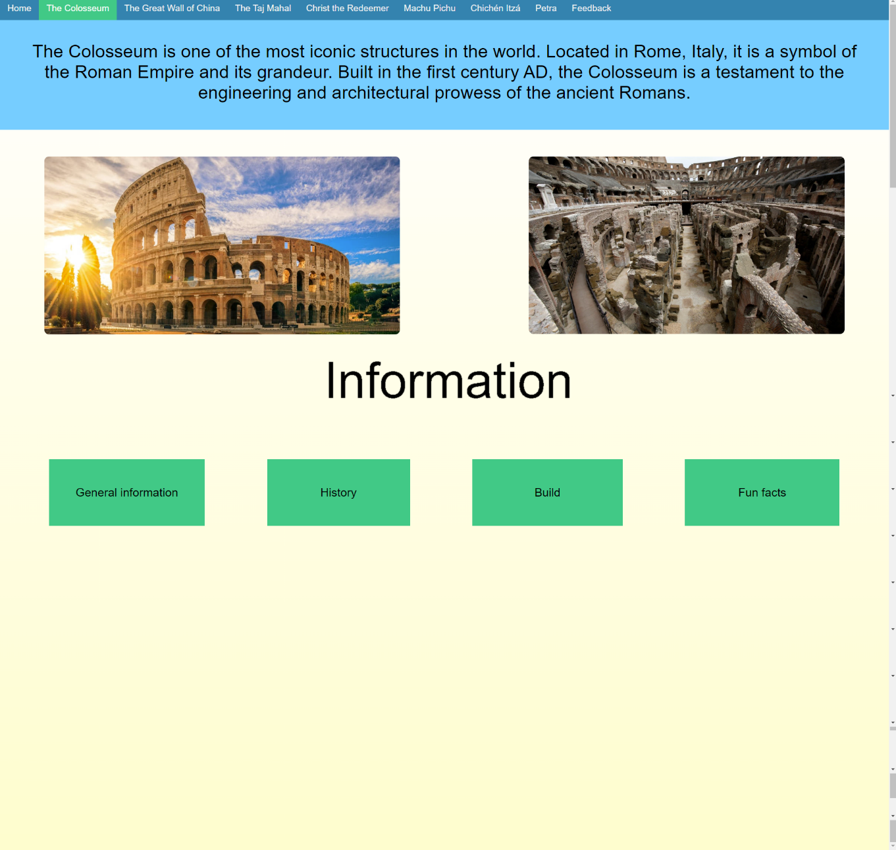 The page in question features two high-resolution images of the Colosseum, one of Rome's most iconic and historically significant structures. These images serve to immediately capture the attention of the visitor and provide a visual representation of the subject matter at hand. Additionally, the page utilises a unique morphing text feature, which serves to guide the visitor to the interactive dropdown menus located on the page. These dropdown menus contain a wealth of information about the Colosseum, including its history, construction, and cultural significance. The dropdown menus are designed to be user-friendly and accessible, revealing information only when hovered over by the visitor, allowing for a more mesmerising and interactive experience. The overall design and functionality of the page has been meticulously crafted to provide an engaging and informative experience for the visitor, allowing them to learn more about this ancient masterpiece of engineering.

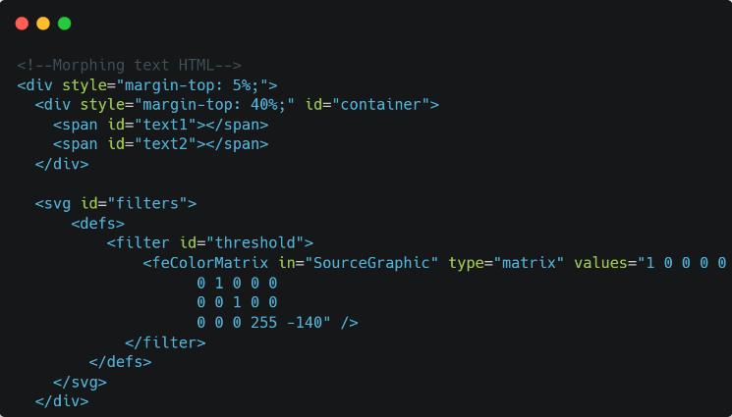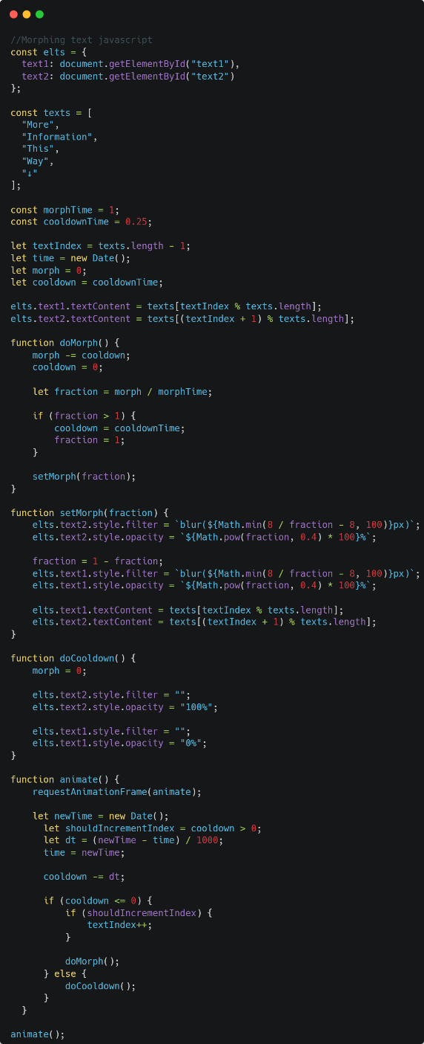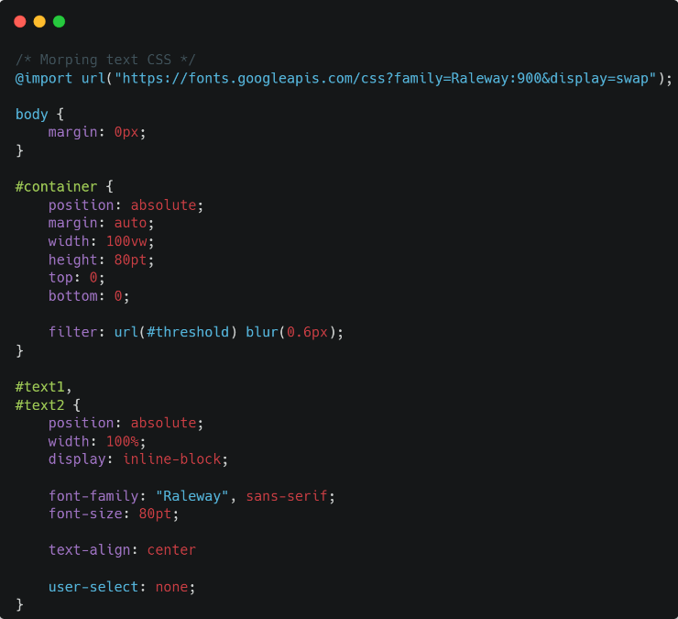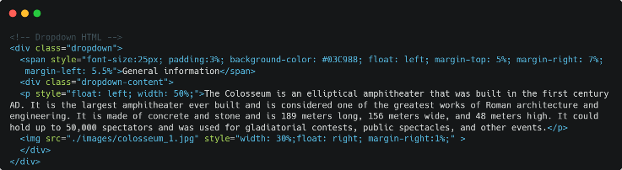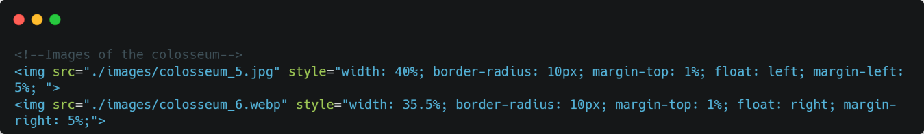

## The Great Wall of China

This page showcases an innovative design, utilizing animated text as headings for each section to provide a dynamic and visually engaging experience for the visitor. Each section contains a wealth of information relevant to the topic at hand, presented in a clear and concise manner. The information is accompanied by a relevant image, providing a visual representation of the subject matter. The use of animated text as headings not only adds a visually striking element to the page, but it also serves to guide the visitor through the content, making it easy to navigate and understand. The overall design and functionality of the page has been carefully crafted to provide an immersive and informative experience for the visitor, effectively communicating the key information in a clear and engaging manner. The use of animation and imagery creates a harmonious balance between aesthetics and functionality, resulting in a page that is both visually striking and informative.

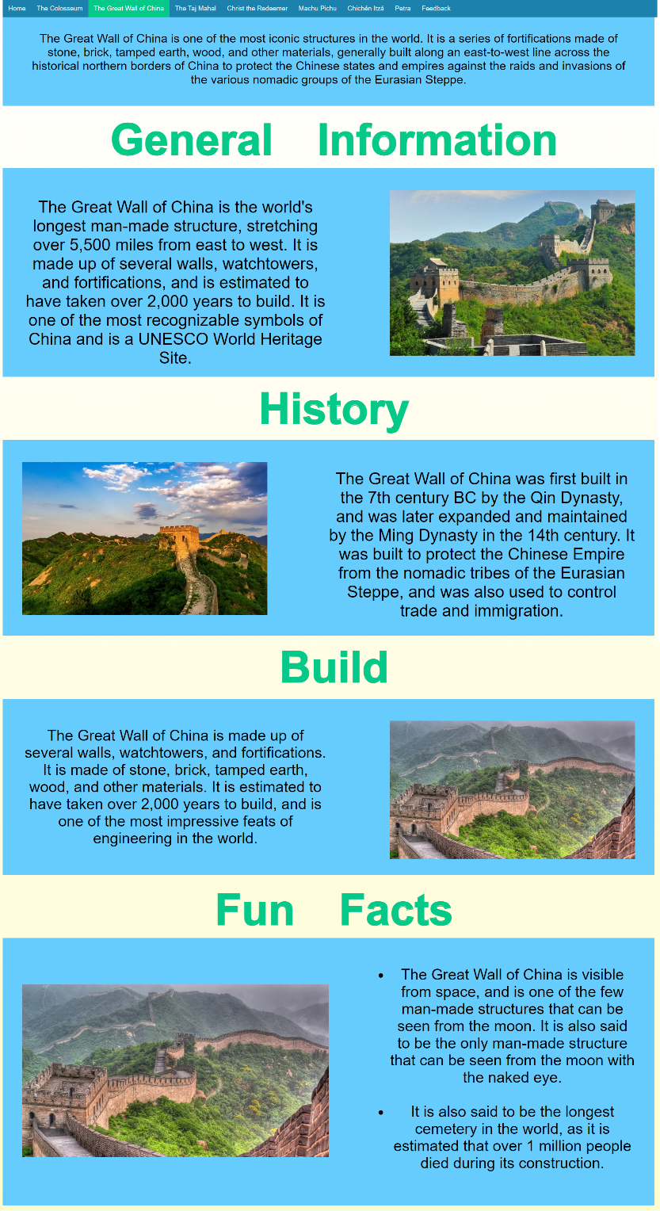

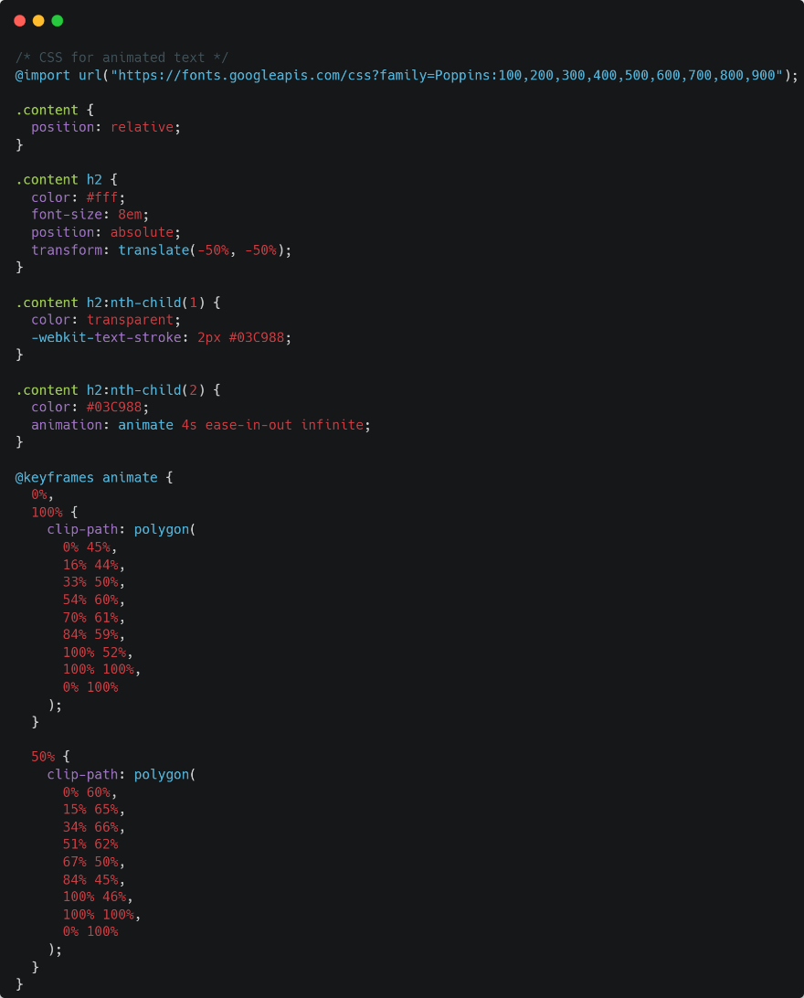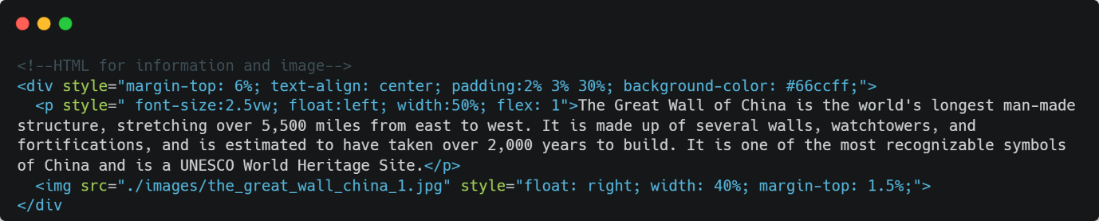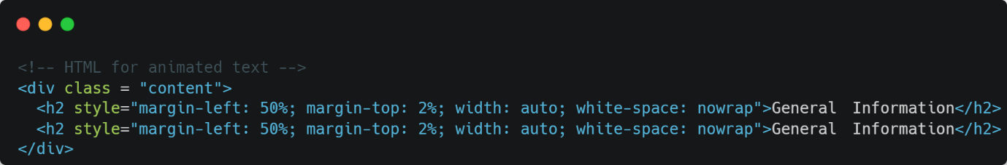

## The Taj Mahal

The page in question features a well-structured and visually pleasing layout, consisting of three distinct columns that present a comprehensive overview of the subject matter at hand. The first column provides general information about the topic, accompanied by an image that serves to enhance the visitor's understanding. The second column delves into the history of the subject, providing a deeper understanding of its background and context, along with an appropriate image. The third column is dedicated to the details of its construction, including technical and architectural information and an accompanying image.

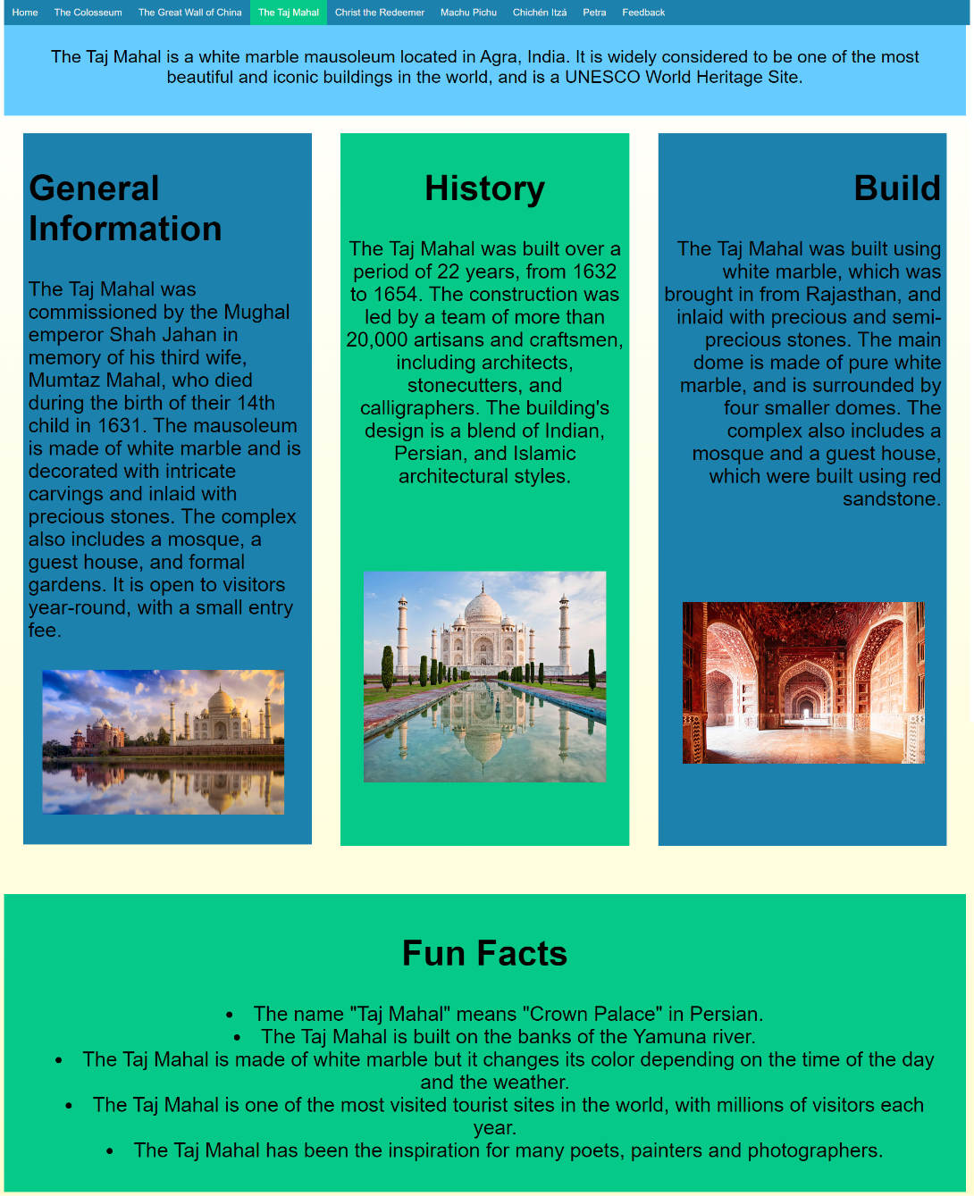In addition to the columns, the page also features a padded box located at the bottom, designed to highlight fun facts and trivia about the subject, this section is also accompanied by an image. The use of images throughout the page serves to supplement the textual information and provide a more hypnotic and engaging experience for the visitor. The overall design of the page is well thought out and executed, effectively organizing the information in a logical and easy-to-navigate manner. The use of imagery, animation and well-structured layout enhances the visitor's engagement and understanding of the subject matter.

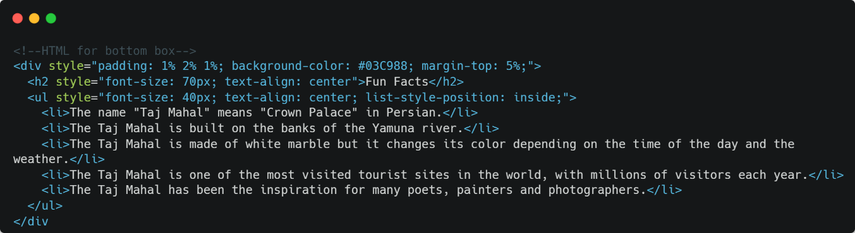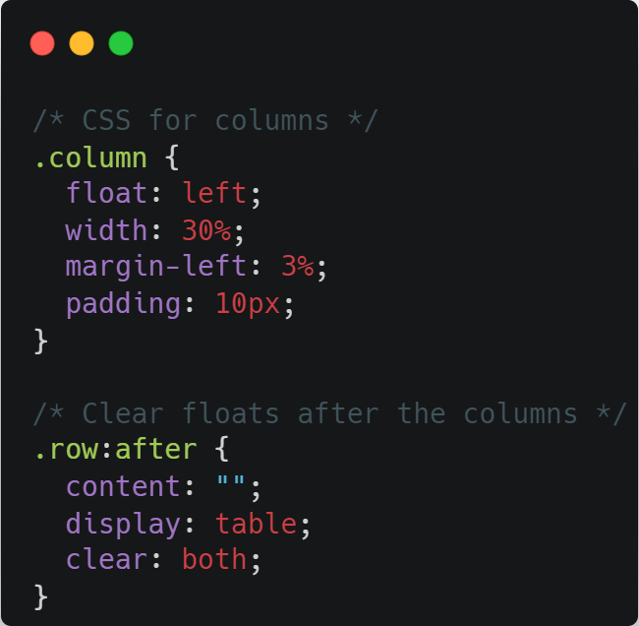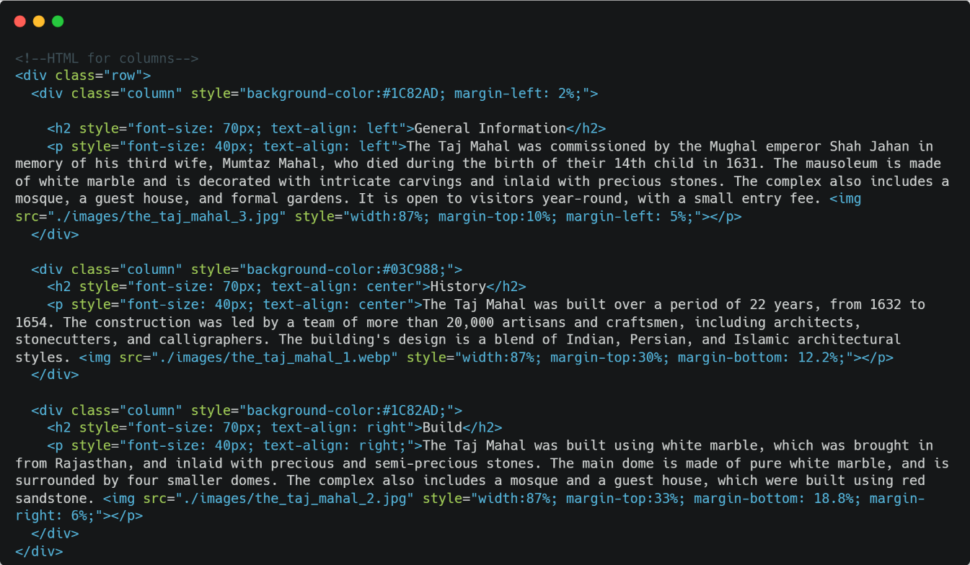

## Christ the redeemer

## The page in question boasts an innovative design that utilises animated text as headings for each section, providing a dynamic and visually engaging experience for the visitor. Each section includes detailed information relevant to the topic at hand, presented in a clear and organized manner. The information is accompanied by a relevant image, providing a visual representation of the subject matter, and enriching the visitor's understanding.

The animated text headings not only add a visually striking element to the page, but also serve as an effective guide for the visitor, making it easy to navigate and understand the content. The page's overall design and functionality have been meticulously crafted to provide an enveloping and informative experience for the visitor, effectively communicating key information in a clear and engaging manner. The use of animation and imagery creates a harmonious balance between aesthetics and functionality, resulting in a page that is both visually striking and informative. Additionally, the use of animation for headings creates a sense of dynamism and engagement that makes it more attractive to the visitors.

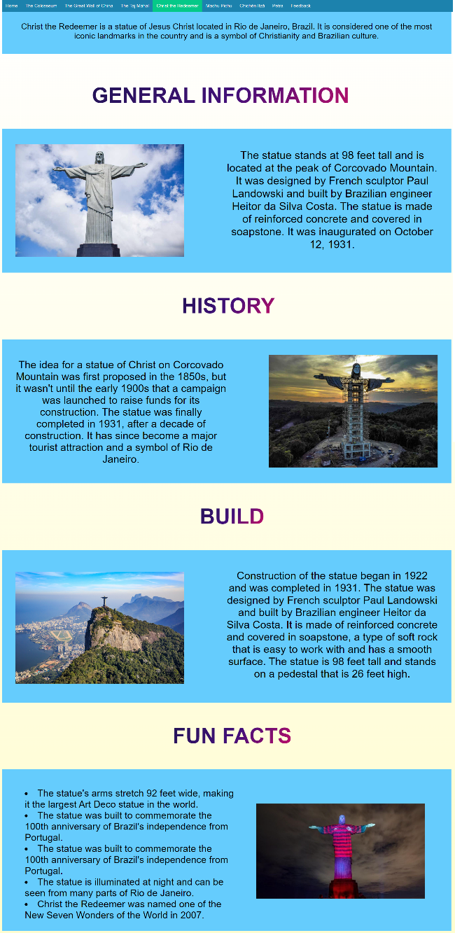

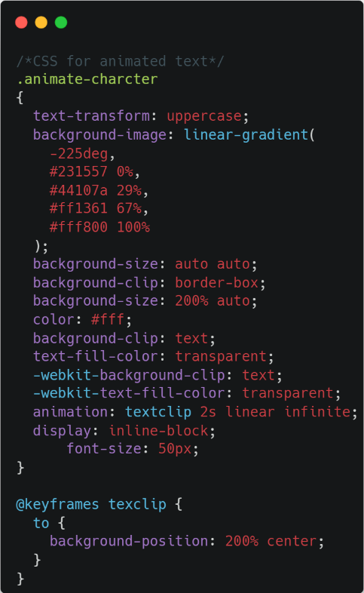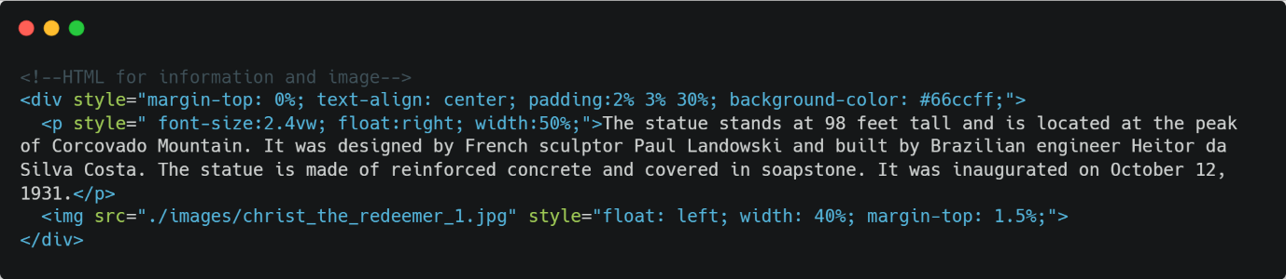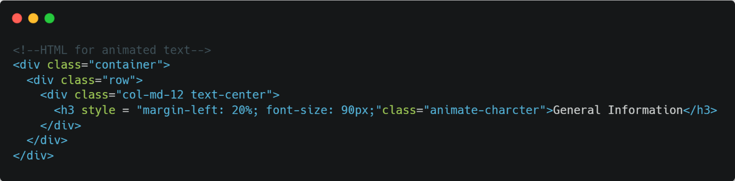

## Machu Pichu

The page in question showcases a highly interactive and user-friendly design, utilizing buttons for each box of information. These buttons serve as an intuitive navigation tool for the visitor, allowing them to easily access and engage with the content.

When a button is clicked, the corresponding information is displayed in an elegant and seamless manner, with the previously displayed information seamlessly disappearing. This innovative design allows for a clean and uncluttered layout, while also providing a dynamic and engaging experience for the visitor. The use of this design pattern makes it easy for the user to switch between different information without having to scroll through irrelevant content.

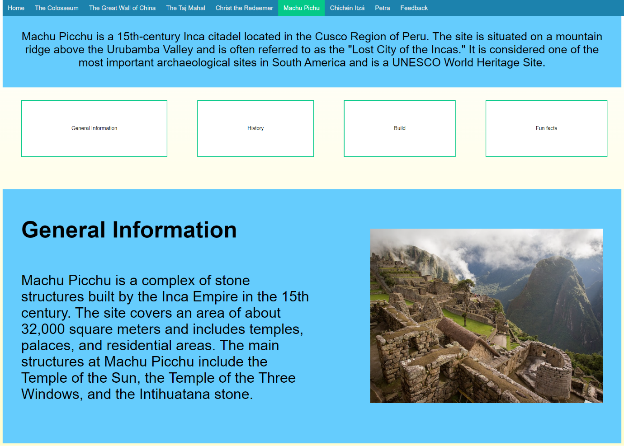The overall design and functionality of the page has been carefully crafted to provide an riveting and informative experience for the visitor, effectively communicating key information in a clear and engaging manner. The use of buttons and seamless animations creates a sense of dynamism and interactivity, making it more attractive and easier to use for the visitors. The design pattern also makes the page more responsive and efficient, as it reduces the amount of content displayed on the page at a time.

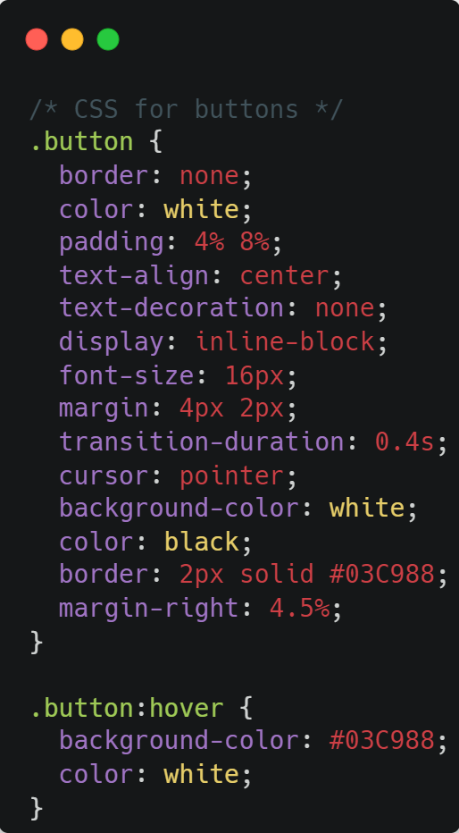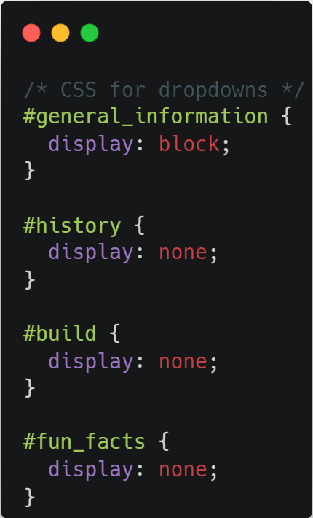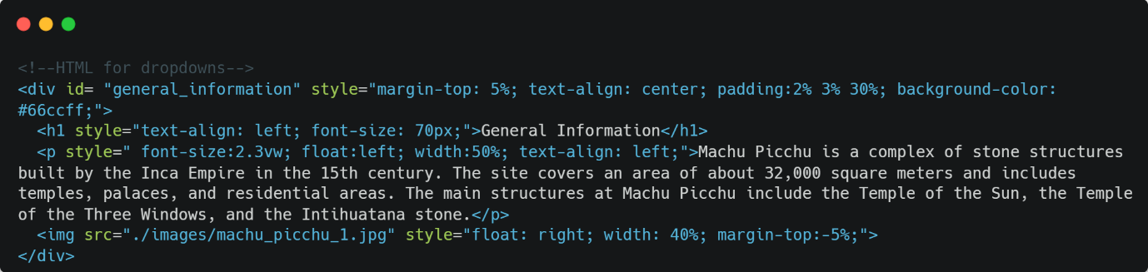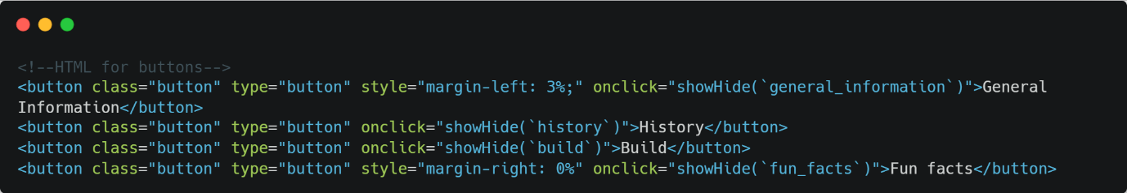

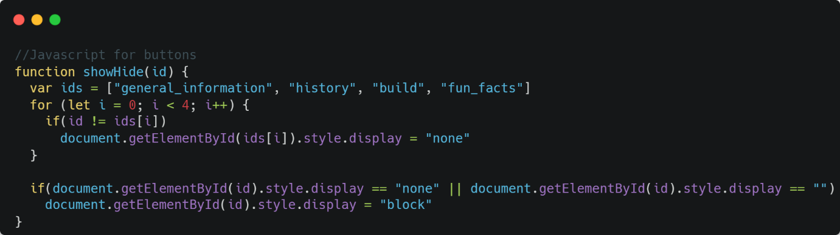

## Chichén Itzá

The webpage in question features a visually pleasing and organized layout, consisting of several boxes that present information on a specific topic. Each box includes a header that serves as a label for the information contained within. The boxes themselves are divided into two distinct sections, one containing an image, and the other containing information related to the header. The placement of the image and information within each box alternates between the left and right sides, providing a visually dynamic and engaging experience for the visitor.

The use of images throughout the page serves to supplement the textual information and provide a more immersive and engaging experience for the visitor. The overall design and layout of the page is well thought out, effectively organizing the information in a logical and easy-to-navigate manner. The use of imagery and well-structured layout enhances the visitor's engagement and understanding of the subject matter. The layout is well balanced, the images and texts are well aligned and the use of white space around the elements make the page easy on the eyes and less cluttered.

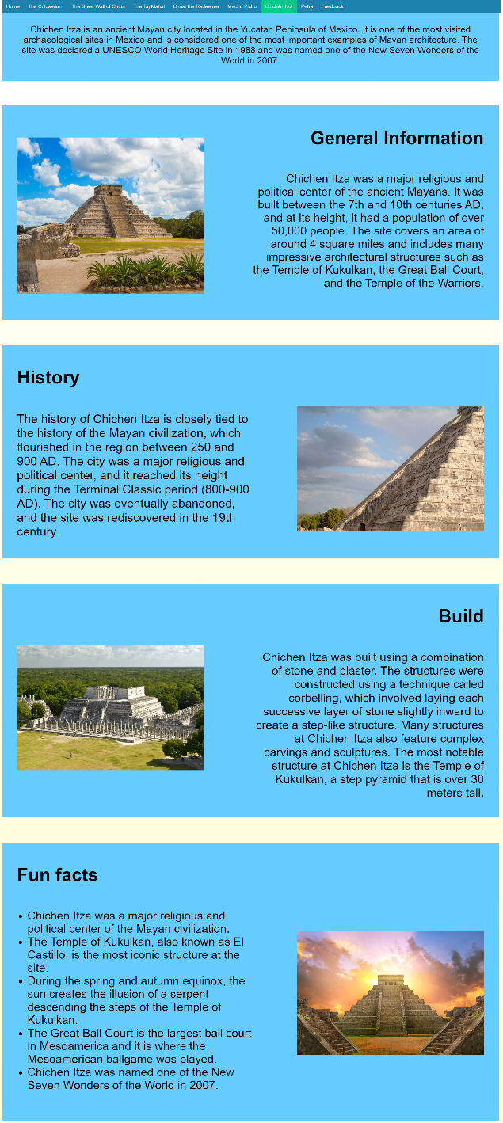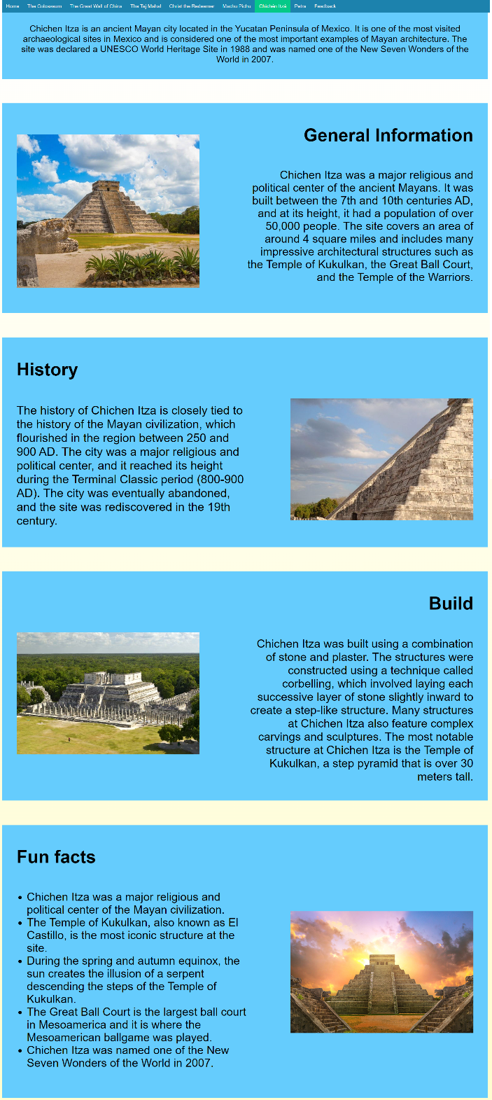The use of alternating layout of image and information within each box creates a sense of visual variety, making it more attractive and engaging for the visitor. The design pattern also enhances the readability of the page, making it easy for the user to find the information they are looking for. The design pattern also makes the page more responsive and efficient, as it reduces the amount of content displayed on the page at a time.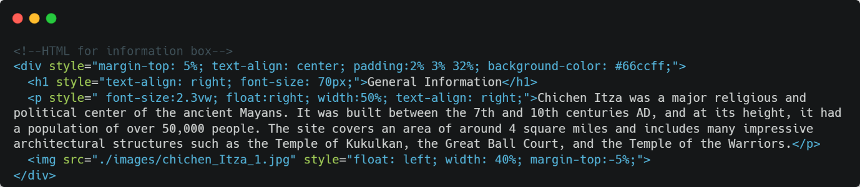

## Petra

## The webpage in question features a carefully designed layout that effectively presents information on a specific topic through the use of several boxes. Each box is composed of a header that serves as a label for the information contained within, and a unique combination of an image and textual information. The placement of the image and information within each box has been expertly crafted to alternate between the left and right sides, providing a visually dynamic and engaging experience for the visitor.

## The use of images throughout the page serves to supplement the textual information and provide a more immersive and engaging experience for the visitor. The overall design and layout of the page is well thought out, effectively organizing the information in a logical and easy-to-navigate manner. The use of imagery and well-structured layout enhances the visitor's engagement and understanding of the subject matter. The layout is well balanced, the images and texts are well aligned and the use of white space around the elements make the page easy on the eyes and less cluttered.

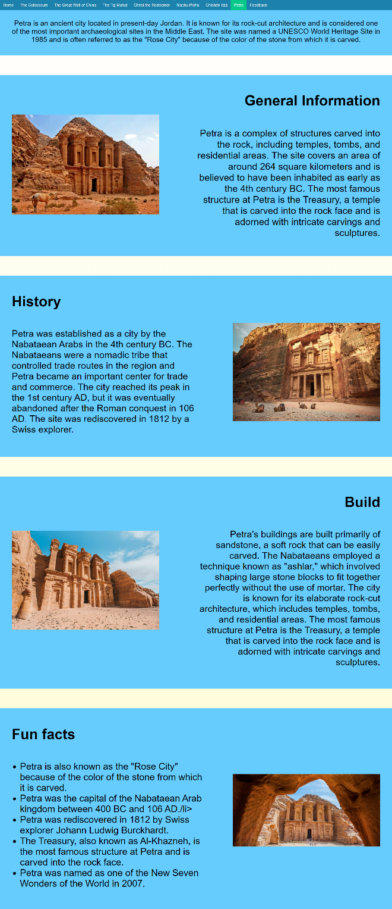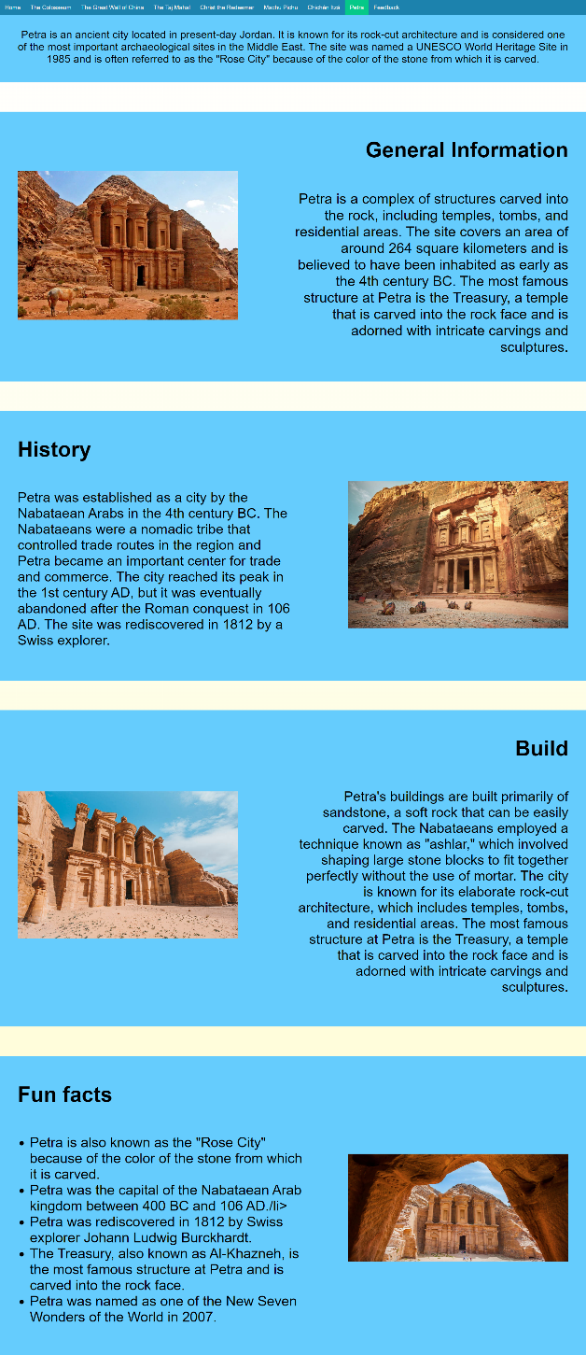The use of alternating layout of image and information within each box creates a sense of visual variety, making it more attractive and engaging for the visitor. The design pattern also enhances the readability of the page, making it easy for the user to find the information they are looking for. The design pattern also makes the page more responsive and efficient, as it reduces the amount of content displayed on the page at a time, while providing an organized and easy-to-use user interface. The page design is intuitive, easy to use and visually pleasing, making it a great tool for delivering information to the visitors.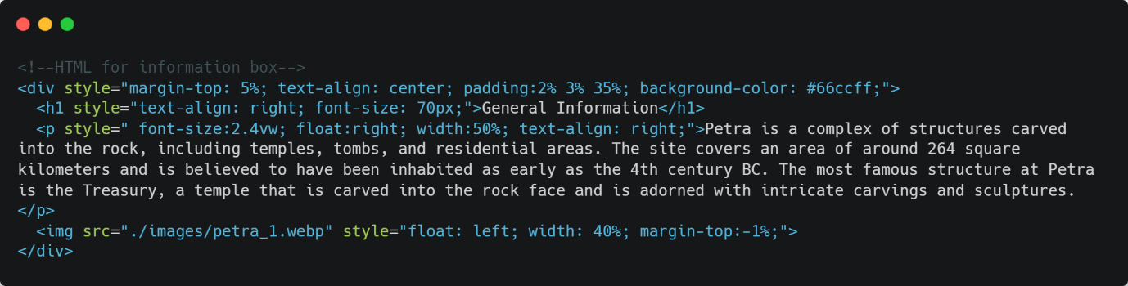

## Feedback

This webpage features an intuitive and user-friendly interface that allows visitors to submit information back to the creators of the website through a well-designed form. The form is composed of 5 fields - First name, Last name, Email address, Wonder visited and message - which have been carefully selected to provide the necessary information for the creators to respond to the user's inquiry. The form fields are well-labeled and easy to navigate, ensuring that visitors can quickly and easily provide their information.

Once the form has been filled in and submitted, a pop-up message appears to thank the user for their submission and clears the form fields to allow for another submission. This feature ensures that the visitor's information is received and processed by the website creators promptly.

The form also includes validation features to ensure that the form is completely filled in before it can be submitted. If the form is not completely filled in, the page will prompt the user to enter their answers in the missing fields, making the process more user-friendly.

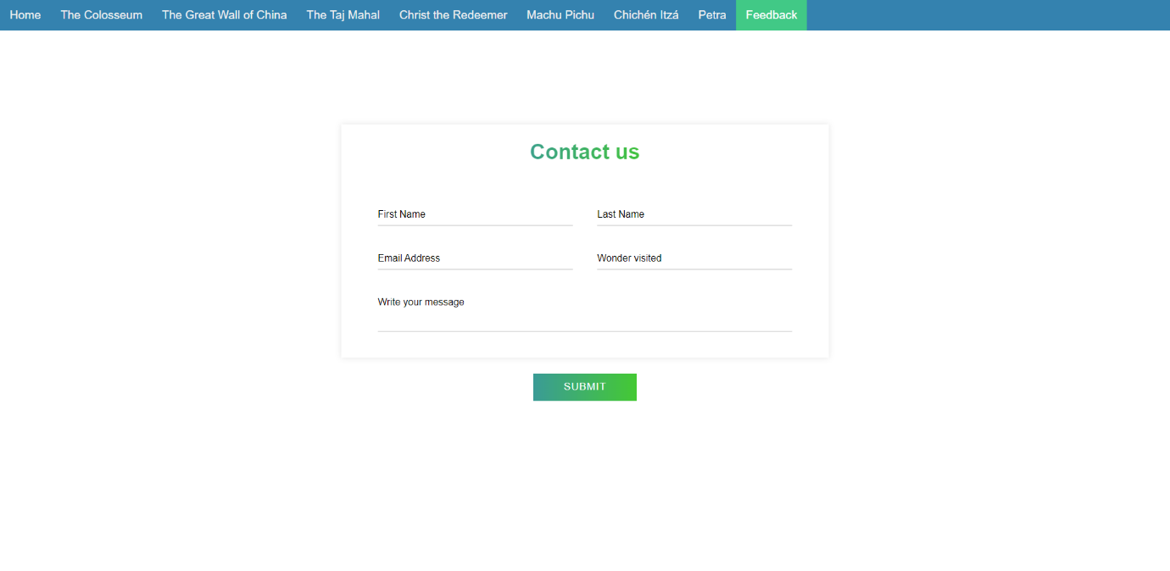In summary, this webpage's form is a well-designed and user-friendly tool that allows visitors to easily submit their information to the website creators, and the validation and thank you feature makes the process more professional and efficient. The form's design and functionality make it easy for visitors to provide their information, while also providing a smooth user experience.

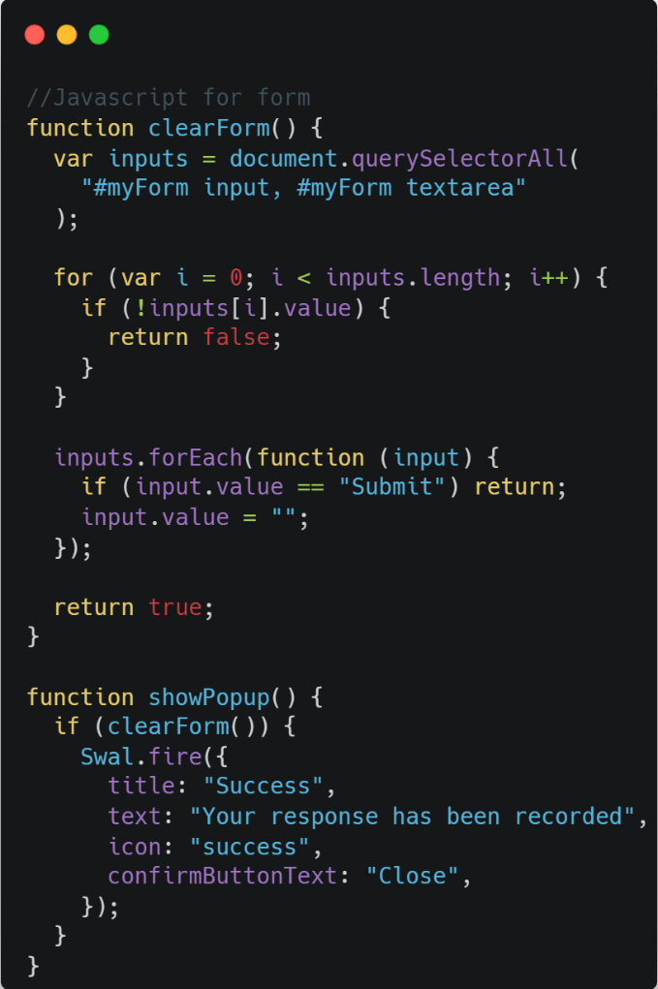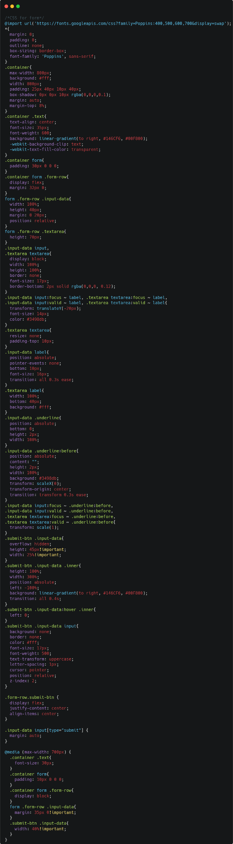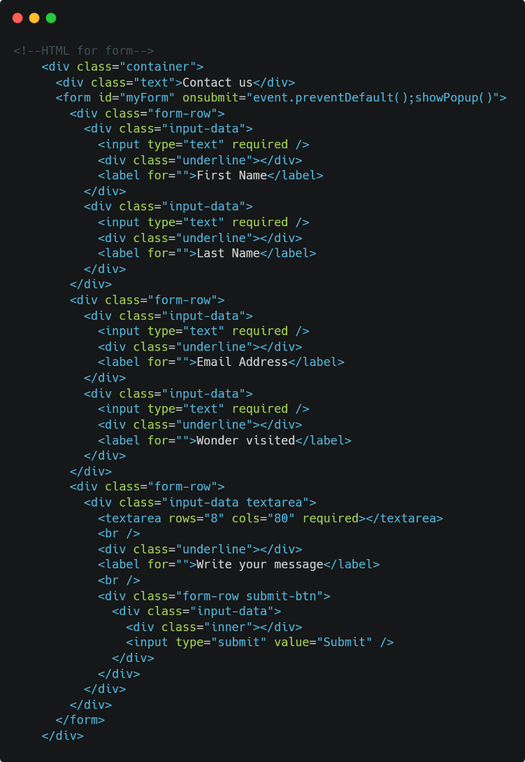

# Testing

|  |  |  |  |  |
| --- | --- | --- | --- | --- |
| **Test no.** | **Test description** | **Expected result** | **Actual result** | **Retest?** |
| 1 | Test the navigation bar on each page is correctly hyperlinked to the right page. | The corresponding page opens once click on the navigation bar. | The corresponding page opens once click on the navigation bar. | No |
| 2 | Test active page highlight | The active page should be a different colour in the navigation bar. | The active page is a different colour in the navigation bar. | No |
| 3 | Test the slideshow changes automatically. | The slideshow should automatically move to the next slide every 5s. | The slideshow automatically move to the next slide every 5s. | No |
| 4 | Test the slideshow buttons. | Buttons should move to the next and previous slides. | Buttons move to the next and previous slides. | No |
| 5 | Test caption changes with slideshow. | Caption should change corresponding to the slideshow image. | Caption changes corresponding to the slideshow image. | No |
| 6 | Test sticky navigation bar. | Navigation bar sticks to the top when scrolling. | Navigation bar sticks to the top when scrolling. | No |
| 7 | Test animated text. | Animated text should change and stay animated. | Animated text changes and stays animated. | No |
| 8 | Test hover over buttons. | Hovering over the buttons should reveal further information. | Hovering over the buttons reveals further information. | No |
| 9 |  | Removing the cursor from the header box or information box should remove the information box. | Removing the cursor from the header box or information box removes the information box. | No |
| 10 | Test images. | Images should load in quickly and be the correct size. | Images load in quickly and are the correct size. | No |
| 11 | Test page icons. | Page icons should quickly load. | Page icons quickly load. | No |
| 12 | Test images and information positions. | Images and text should be in the correct position on each page. | Images and text are in the correct position on each page. | No |
| 13 | Test feedback form. | Each field should be in the correct position and animate when pressed. | Each field is in the correct position and animate when pressed. | No |
| 14 |  | The form should prompt you to fill in empty fields when pressing submit. | The form prompts you to fill in empty fields when pressing submit. | No |
| 15 |  | Pressing the submit button should clear all values. | Pressing the submit button clears all values. | No |
| 16 |  | Pressing submit button, when all the fields are filled, should present a popup thanking for the submission. | Popup appears on home network but not school network. | Yes |
| 17 | Testing YouTube video | YouTube video should load, and visitors should be able to play it. | YouTube video loads correctly and visitors are be able to play it. | No |

# Retests

|  |  |  |  |  |
| --- | --- | --- | --- | --- |
| Repeated Test No. | Test description | Expected Result | Actual result | Retest valid? |
| 16 | Test feedback form | Pressing submit button, when all the fields are filled, should present a popup thanking for the submission. | Pressing submit button, when all the fields are filled, presents a popup thanking for the submission. | Yes |

The issue was resolved by implementing a solution of storing the popup script locally, instead of retrieving it from an external source.

This change not only enhanced the page loading speed, but also ensured the reliability of the script in terms of security and data privacy.

The local storage of the popup script reduced the dependency on an external resource, thereby eliminating any potential delays or hindrances in loading the page.

This modification resulted in a significant improvement in the overall user experience and performance of the webpage.

# Evaluation

Overall, the website demonstrates a high level of performance and effectively meets all of the key requirements. The well-designed navigation bar greatly facilitates ease of use, thereby encouraging visitors to remain on the site and explore its various features. Each page presents detailed information, complemented by a range of informative images, in order to provide the visitor with a comprehensive understanding of the subject matter.

The carefully selected colour scheme has been created with the aim of promoting visual comfort and has proven to be effective in achieving this goal. Additionally, the website's variety of components effectively sustains the visitor's engagement and interest, thereby contributing to increased traffic and an improved user experience. The implementation of various animations, such as text animations, serves to enliven the site and make it more engaging. The presence of a feedback page enables visitors to submit their thoughts and opinions, thereby creating a sense of inclusion and contributing to their overall satisfaction.

While time constraints limited the ability to include certain advanced features in the final product, such as the option to save feedback locally on the server using NodeJS, the website still delivers a highly functional and well-rounded user experience.